|  |
| --- |
|  |
|  |
|  |
|  |

Name: Joseph Tierney

Class: Computer Science 1B – Web Authoring

Project Title: ePortfolio Website

Submission Date: 02/12/14

**1. Introduction**

As part of my FETAC level 5 Web Authoring module, I have been tasked with designing an ePortfolio website for myself. The ePortfolio website will intend to give a potential employer basic information about myself and my history with my current course, as well as a previously attended course.

My ePortfolio website will include four main links; a Home page, which will have an introduction to the website as well as a picture of myself.

There will also be an About Me section on the page, which will give information about my previously attended college, as well as my current college, Coláiste Dhúlaigh.

The next link will be a Contact Me page, which gives the viewer my basic contact details, along with a Facebook link and a Twitter link, both accounts are made specifically for this and are considered my work pages. Along with these, the viewer will be able to leave their contact details if they wish.

The final page will be a PDF format of My CV.

|  |
| --- |
| **2. Research Part A:**  Research of existing ePortfolio website layouts:  <http://www.gregone.com> |
| gregone  This website has a simple layout, and easy on the eye colours. As one can see, it’s very easy to distinguish the main sections of the site, and the navigation bar is user friendly.  <http://www.cssloggia.com/2008/05/20/studio-skitz/>  07-33_studio_skitz |
| This website is a bit more advanced than the previous one, as you can see he uses colourful and eye catching images in the background, as well as having a table of all his work on the left of the page. |
|  |

|  |
| --- |
| **3. Research Part B:** |
| Web Design I Like  <https://sites.google.com/site/positivelysmashing/home>    Simple use of colours, contrast between the dark grey background and white body text. Navigation is made easy by the placement of links, along with the white rollover that each link gives. |
|  |

|  |
| --- |
| **4. Research Part C:** |
| Research into type, navigation colour schemes, headers and footers.  <http://udel.edu/~alexreid/Alexandra_Reids_ePortfolio/Home.html>    Liked the idea of using a signature in the header. Attempted it in my final design, but instead swapped it out for a signature in the footer as I felt it would look a lot better.  <http://katieroyceeportfolio.wikispaces.com/> |
|  |

Liked the use of an image in the header, integrated this into my final design.

<http://mrwalterswebsite.com/about/>

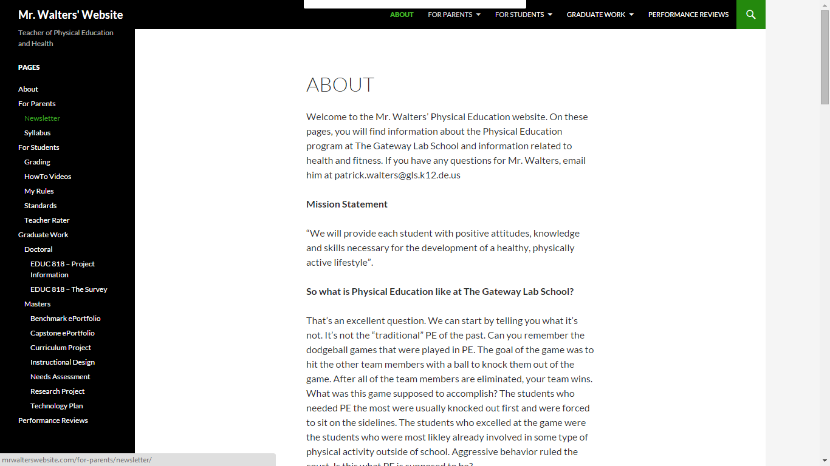

Liked the idea of the page links staying the same colour until you scrolled over them. Added this to my web page to make the links turn red when scrolling over them.

|  |
| --- |
| **5. Preparatory work Part A:** |
|  |
|  |

|  |
| --- |
| **6. Preparatory work Part B:** |

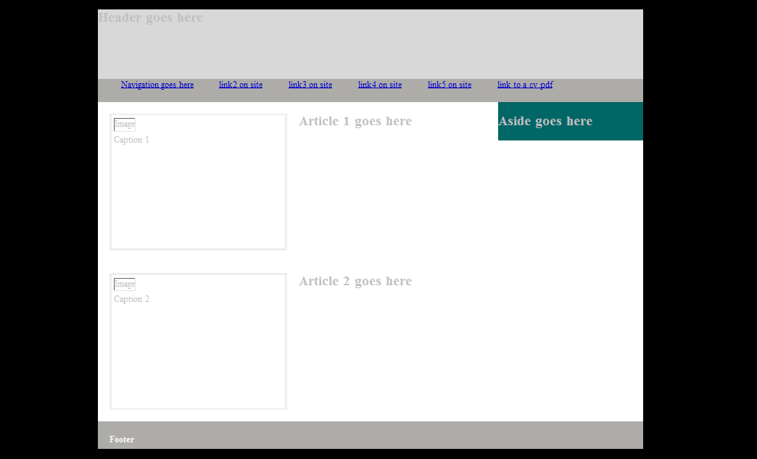

First draft of my website, not happy with background colour scheme, or the amount of links in the navigation bar, which is changed in the final design. Not fond of initial font colour or the aside heading and colour.

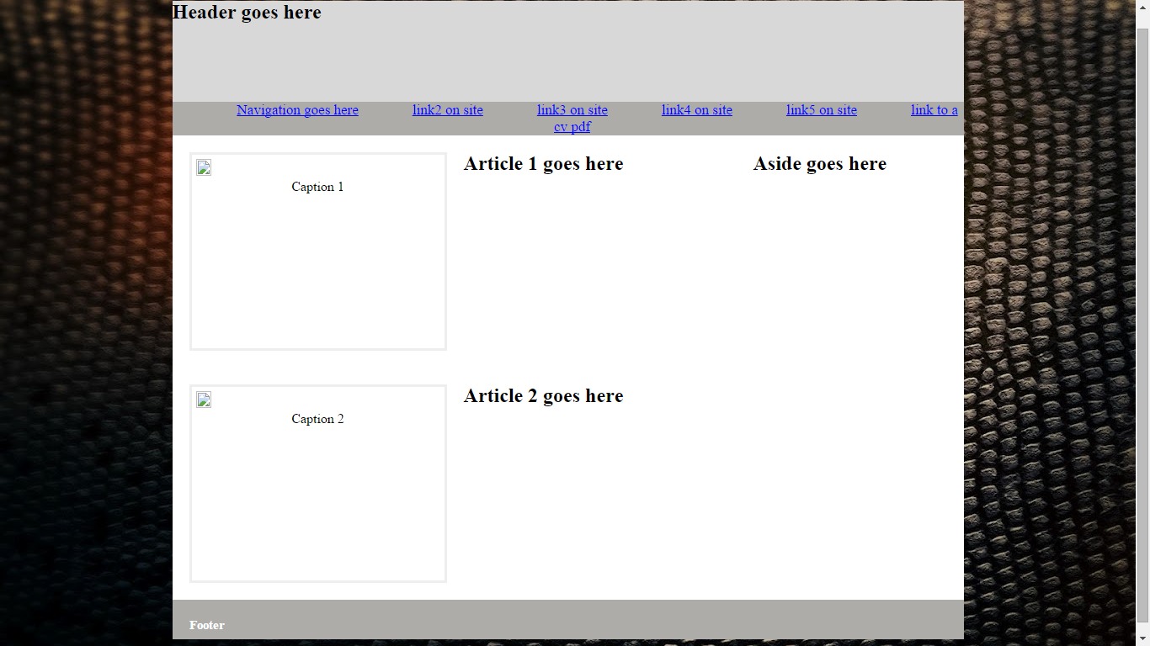

Second draft of my website. Changed background to an image, changed font colour to black to go well with the white background, also got rid of the aside colouring heading

**7. Finished Website**

**Home Page:**

|  |
| --- |
| finishedsite1 |
| **About Me Page:** |

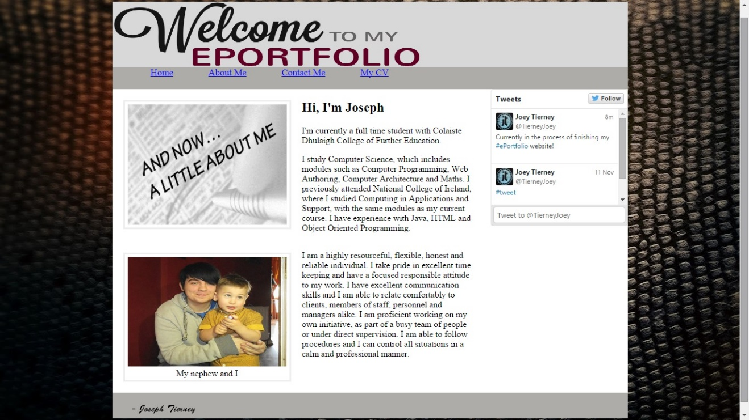

**Contact Page:**

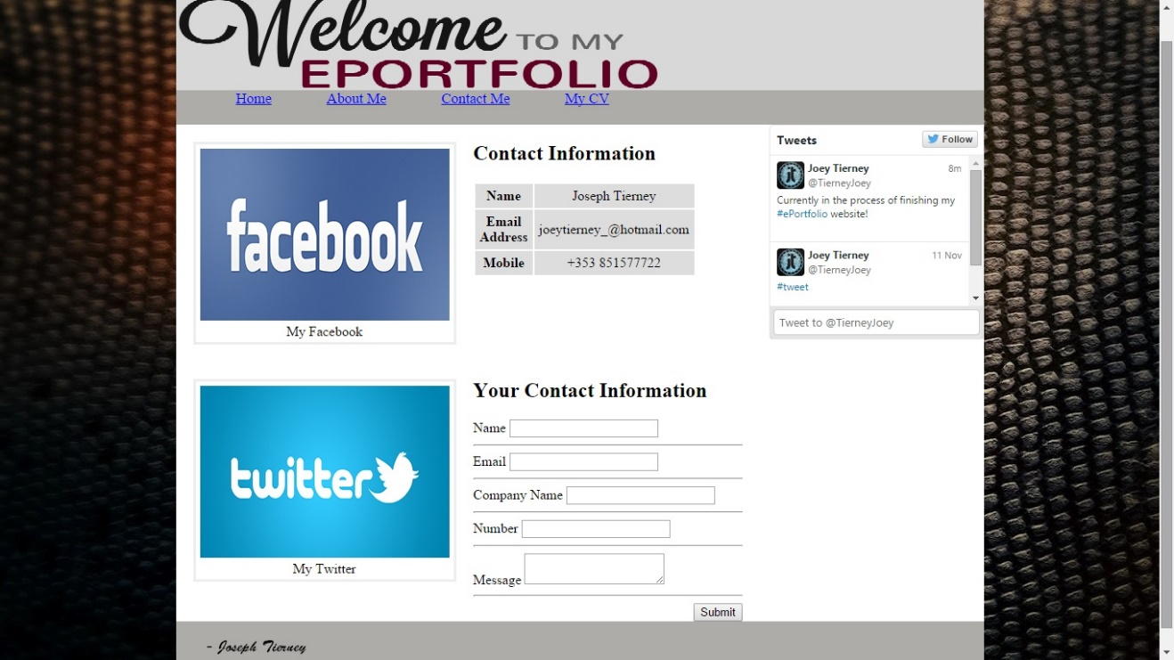

**CV Page:**

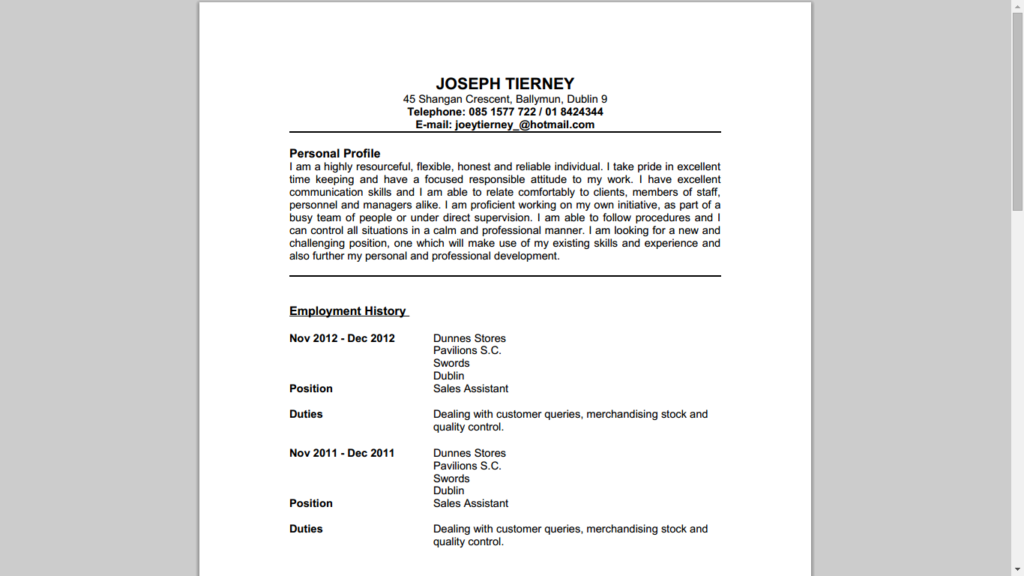

**8. Conclusion and Evaluation**

I like the overall design of my website. I find that it’s easy to use and navigation, and feel that it gives the appropriate amount of information about myself and some of my experiences with the computer science course. I’ve tested the website out on the three main browsers (Google Chrome, Firefox and Internet Explorer) and it works as intended on all of them with no differences. All the links on the website work, and link to the page they are supposed to link too and I feel that the Twitter timeline fits in well with the overall design and it gives it that professional feel.

I also find that giving the visitor the option to leave their contact details was a nice addition, as it lets me contact them if I miss their call.

Although I like my website, I feel that there could be improvements to make the overall design look better, as well as some improvements to make the additional content better as well.

I originally intended on adding a music player to the header, playing a selection of some of my favourite songs, with the option to click Next, Back, Play and Pause, along with a mute option.

Adding a Facebook box with the option to like my work page would also add to the professional feel.

Overall, I am happy with the outcome of my website and feel that the slight improvements would it make it better.

**9. index.html source code**

<!DOCTYPE html> <!-- HTML5 -->

<html>

<head>

<title>ePortfolio</title>

<link rel="stylesheet" href="css/style.css" /> <!-- link to css stylesheet style.css -->

</head>

<body>

<div class="wrapper"> <!-- Wrapper for webpage set at 940px in style.css-->

<header> <!-- start of header -->

<h2> <img src="images/eport.png"/> </h2>

</header> <!-- /header -->

<nav> <!-- start of navigation -->

<ul>

<li><a href="index.html">Home</a></li>

<li><a href="about.html">About Me</a></li>

<li><a href="contact.html">Contact Me</a></li>

<li><a href="cv.pdf">My CV</a></li>

</ul>

</nav> <!--/navigation -->

<section> <!-- start of main page content -->

<article><!-- start of article -->

<figure>

<img src="images/welcome2.jpg"/>

</figure>

<h2>Introduction</h2>

<p>Welcome to my ePorfolio. I thank you for taking the time and expressing the interest to read about my experience

with programming, web authoring, or whatever it may be that brought you here! This website is divided into four pages,

each giving you different information about myself and my experience with life, other work adventures, and computers (in general).</p>

</article> <!--/article -->

<article> <!-- start of article -->

<figure>

<img src="images/cj.jpg"/>

<figcaption>As recommended by wrestling legend Chris Jericho</figcaption>

</figure>

</article> <!--/article -->

</section> <!-- /main page content -->

<aside> <!-- start of aside -->

<a class="twitter-timeline" href="https://twitter.com/TierneyJoey" data-widget-id="537321932174401536">Tweets by @TierneyJoey</a>

<script>!function(d,s,id){var js,fjs=d.getElementsByTagName(s)[0],p=/^http:/.test(d.location)?'http':'https';if(!d.getElementById(id)){js=d.createElement(s);js.id=id;js.src=p+"://platform.twitter.com/widgets.js";fjs.parentNode.insertBefore(js,fjs);}}(document,"script","twitter-wjs");</script>

</aside> <!--/aside -->

<footer> <!-- start of footer -->

<h3><img src="images/sig.png"/></h3>

</footer> <!--/footer -->

</div><!-- /wrapper -->

</body>

</html>

**10. style.css source code**

header, section, footer, aside, nav, article, figure, figcaption {

display: block;}

body {

color: #000000;

background-image: url("background.jpg");

background-color: #191919;

margin: 0px;

}

.wrapper {

width: 940px;

margin: 20px auto 20px auto;

background-color: #FFFFFF;

}

.buttonHolder{

text-align: right;

}

p {

font-family: "Times New Roman", Times, sanserifserif;

}

header {

height: 120px;

background-color: #D8D8D8 ;

}

nav, footer {

clear: both;

color: #ffffff;

background-color: #aeaca8;

height: 40px;

}

nav ul {

margin: 0px;

text-align: center;

display: inline-block;

}

nav li {

display: inline;

margin: 30px;

font-size: 17px;

}

section {

float: left;

width: 659px;

}

article {

clear: both;

overflow: auto;

width: 100%;

background-color: #FFFFFF;

}

table{

width: 215px;

border: 10px #000000

}

th, td{

text-align: center;

background-color: #dddddd;

padding: 5px;

width: 100px;

}